Programming Assignment 3 Instructions

Mark 16:15
He said to them, “ Go into all the world and preach the good news to all creation”

It is very important to share the Word with others. One of the ways to do this is through mission trips where not only are you the hands and feet of Jesus but also you provide His Word.

This week you are going to create a Visual Basic program which produces a quote for mission teams. The user should enter the Name of the Group, the location of the mission trip, the number of people going on the trip, the number of days, and the choice of insurance.

- Design your screen to look like the one below.
- Store the amounts entered by the user in variables and use these variables in the formula.
- A processing fee in the amount of $250 must be stored in a constant variable
- The following locations should be stored in a listbox:
  - Africa – price per day $500
  - United States – price per day $100
  - Haiti – price per day $400
  - Mexico – price per day $200
- Use appropriate naming conventions for controls and variables.
- Include internal documentation to describe the logic in your program (i.e. put comments in your code).
- Tab Control must flow in order and not go to the lstbox.
- The Calculate Button will do the following:
  - The results listbox should be cleared before displaying the new results.
  - The information that was entered should be checked to make sure there are values entered. If the user entry contains null values, the user should be so advised, and the user should be directed to the text box that contains the error. Make sure your error messages are meaningful.
  - Determine if insurance is wanted based on the value of the checked box. Set the value of insurance to zero if the option is not checked and 300 if the option is checked.
  - Determine the price per day depending on the location selection. You must show you can use a case statement for this decision.
  - Calculate the cost for the total trip using the calculation below:
((number of people) * (daily cost of trip) * (number of days)) + insurance amount + fee
  - Using the output below, display the following information using the appropriate spacing
    - *****In the lstBox you must include the mission coordinator (your instructor) and the guide (your name). This is a requirement for the assignment to be accepted.
    - The Group Name – Must be converted to upper case before displaying
    - The Location of the Trip
    - The number of people going
    - The daily cost per person
    - The number of days
    - The insurance amount for the trip formatted as currency
    - Total cost of trip formatted as currency

This assignment is due by 11:59 p.m. (ET) on Monday of Module/We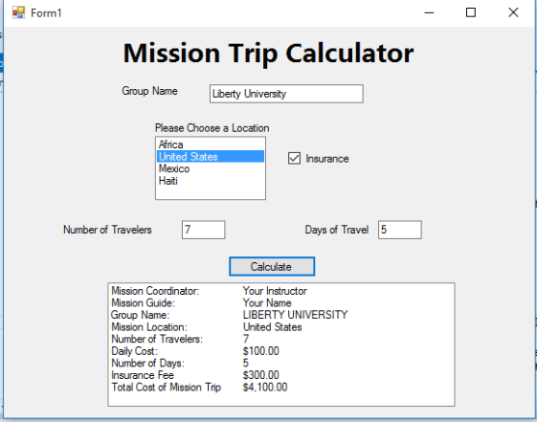ek 2.

Adapted from Schneider, D. I. (2010). Introduction to Programming Using Visual Basic 2010 (8th ed.).

